**Percent of total test grade — 50**

**DIRECTIONS: Please complete the following program according to the specification given. Remember that all program segements are to be written in Java.**

Partial credit will be given for incomplete answers, so provide as much of the answer as you can.

Notes:

* Assume that the classes listed in the Quick Reference found in the Appendix have been imported where appropriate.
* Unless otherwise noted in the question, assume that parameters in method calls are not null, and that methods are called only when their preconditions are satisfied.
* In writing solutions for each question, you may use any of the accessible methods that are listed in classes defined in that question. Writing significant amounts of code that can be replaced by a call to one of these methods may not receive full credit.

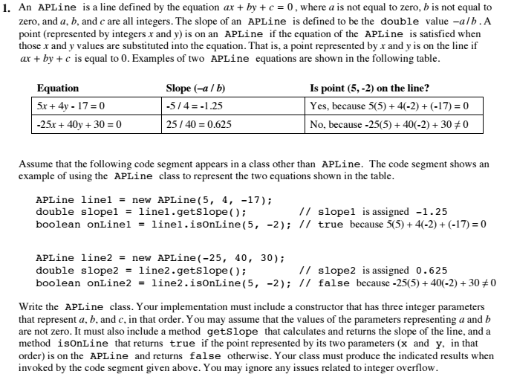

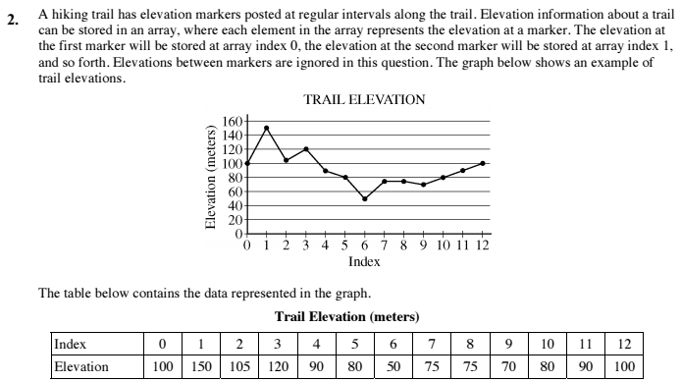

**END OF SECTION II.**

